Environmental Migration
Environmentally caused migration is a natural type of forced migration. Environmental disasters are one of the most destructive forces on our planet and of the strongest push factors for migration. The range of natural disasters that force people to migrate is wide. From floods, to droughts, to earthquakes, every one of those may cause a large forced migration.

Floods – Powerful Destroyers
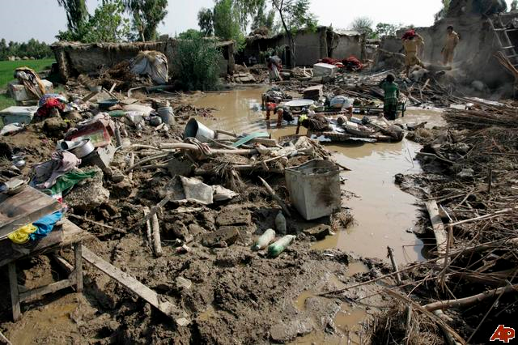
Floods are one of the most widespread natural disasters. They occur all over the world and affect millions of lives every year. Destruction caused by floods can last for years afterwards and render land empty where once towns and villages stood. Their destructive power forces thousands of people to migrate from the affected areas to other places. Floods may vary in size from local rivers flooding the streets, to widespread chaos and destruction. The effects on migration are sewer by large scale floods.
While in some cases it may just force the people to move within the country, in other cases the economy may be so badly damaged that they are forced to migrate into other countries.
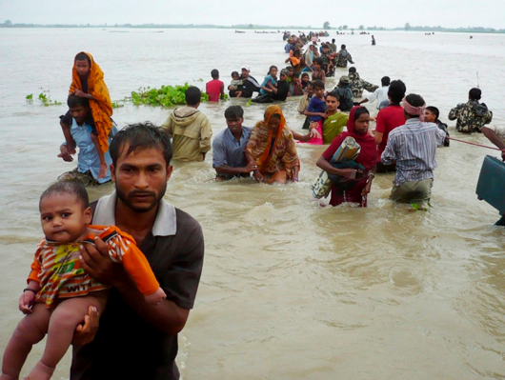
With floods a lot of people try to return after the area has been rebuilt, since they didn’t migrate willingly but it often takes years.
Floods occur where there is water; this also makes them one of the most in inevitable dangers to account for all over the world.

