Economic Migration
Economic Migration is the most common of unforced migration. It has been part of human culture since the very beginning when hunters would travel far to find new hunting grounds, to the enormous rural to urban migration in the 19th century during the Industrial Revolution.

China – Rural to Urban Migration
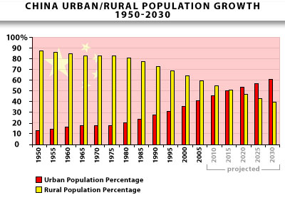
China is a good example of economic migration. China is still in the transition period from a traditional rural society to a modern urban society as we find it in most developed nations nowadays. Since the 70’s Chinas urban population has almost doubled, this coincides with the rise of China to an industrialized economic power. The traditional Chinese society was based much on farming, as were the societies of most nations before the 18th century. This farming society lasted throughout the first half of the 20th century with the urban population slowly growing, but not as quick as it would after the Industrialization in the 70’s.
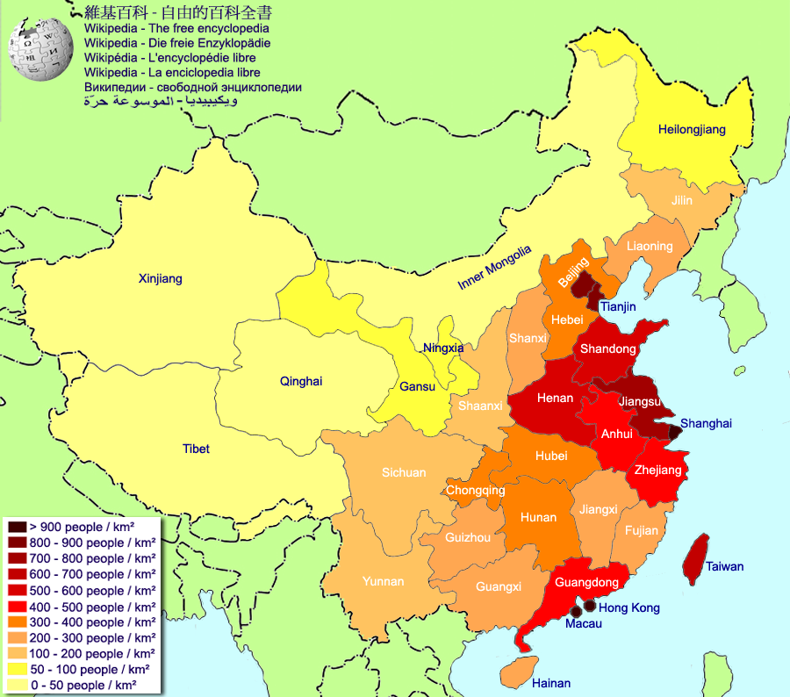
Machines were introduced to farming and productivity rose to a point where a lot of workers weren’t needed in farming any more. They instead went to work in factories in the major cities of the country. Many farmers migrate to the cities where jobs in the there built factories seemingly offer them a much higher income than farming and with that a higher standard of living. The enormous amount of people streaming into the cities causes problems such as lack of housing and infrastructural issues.
Nonetheless the people come. On one side they are pushed by the lack of jobs in farming and pulled by the promise of higher income and a raise in their standard of living. These and many more push and pull factors affect the economic migration within China.

